# VISVESVARAYA TECHNOLOGICAL UNIVERSITY

JNANA SANGAMA, BELAGAVI – 590 018



**An Internship Project Report on**

***STOCK MARKET PREDICTION***

*Submitted in partial fulfillment of the requirements as a part of the*

# AI/ML INTERNSHIP (NASTECH)

*For the award of degree of*

## Bachelor of Engineering in

**Information Science and Engineering**

Submitted by

## NIKITA PYATI PADMACHANDANA N

**1RN19IS095 1RN19IS097**

### Internship Project Coordinators

**Dr. R Rajkumar Mrs.Sunitha K**

**Associate Professor Assistant Professor**

**Dept. of ISE, RNSIT Dept. of ISE, RNSIT**

**Department of Information Science and Engineering RNS Institute of Technology**

Channasandra, Dr. Vishnuvardhan Road, RR Nagar Post, Bengaluru – 560 098

**2021 -2022**

**RNS Institute of Technology**

**Channasandra, Dr. Vishnuvardhan Road, RR Nagar Post, Bengaluru – 560 098**

**DEPARTMENT OF INFORMATION SCIENCE & ENGINEERING**

**CERTIFICATE**

This is to certify that the mini project report entitled ***STOCK MARKET PREDICTION***

has

been

successfully

completed

by **NIKIT PYATI**

bearing

USN

**1RN19IS095** and

**PADMACHANDANA N** bearing USN **1RN19IS097**, presently VII semester students of **RNS**

**Institute of**

**Technology**



in partial fulfillment of the

requirements

as a part

of the

***AI/ML***

***Internship (NASTECH)*** for the award of the degree of ***Bachelor of Engineering in Information Science and Engineering*** under **Visvesvaraya Technological University, Belagavi** during academic year **2021 – 2022**. It is certified that all corrections/suggestions indicated for Internal Assessment have been incorporated in the report and deposited in the departmental library. The mini project report has been approved as it satisfies the academic requirements as a part of Mobile.

**Dr. R Rajkumar Mrs. Sunitha K Dr. Suresh L**

Coordinator Guide Professor and HoD

Associate Professor Assistant Professor

**External Viva**

**Name of the Examiners Signature with date**

1.

2.

# ABSTRACT

In stock market prediction, the aim is the future value of the financial stocks of a company. The recent trend in stock market prediction technologies is the machine learning to predict stock values. Factors considered are open, close, low, high, volume

In present days so many people's are interested in investing money in stock market for earning more in short period of time.

Here ,in stock market consist of many number of company shares along with prices in stock market every minute stock price will changes depending on the company environment and country economic structure decisions. In stock market there are many broker's for handing the stocks buying and selling between the clients and company. In previous year's there is difficult to predict the stock market because lack of technology and knowledge but in present days technology will increases day by day for that we can predict the stock market easily when compare to past here we can predict stock price by analyzing the previous data by using machine learning techniques. From these techniques we can use neural network(it's means that it is interconnected with networking it look like human neural brain structure) and simple moving average method.

A stock market is a public market where you can buy and sell shares for publicly listed companies. The stocks, also known as equities, represent ownership in the company. The stock exchange is the mediator that allows the buying and selling of shares.

Stock price analysis has been a critical area of research and is one of the top applications of machine learning. This tutorial will teach you how to perform stock price prediction using machine learning .

# ACKNOWLEDGMENT

The fulfillment and rapture that go with the fruitful finishing of any assignment would be inadequate without the specifying the people who made it conceivable, whose steady direction and support delegated the endeavors with success.

We would like to profoundly thank **Management** of **RNS Institute of Technology** for providing such a healthy environment to carry out this AI/ML Internship Project.

We would like to express our thanks to our Principal **Dr. M K Venkatesha** for his support and inspired us towards the attainment of knowledge.

We wish to place on record our words of gratitude to **Dr. Suresh L,** Professor and Head of the Department, Information Science and Engineering, for being the enzyme and master mind behind our Mobile Application Development Laboratory with Mini Project Work.

We like to express our profound and cordial gratitude to my Internship Project Coordinators**, Dr. R Rajkumar,** Associate Professor, Department of Information Science and Engineering for their valuable guidance, constructive comments, continuous encouragement throughout the Mini Project Work and guidance in preparing report.

We would like to thank all other teaching and non-teaching staff of Information Science & Engineering who have directly or indirectly helped us to carry out the Mini Project Work.

Also, we would like to acknowledge and thank our parents who are source of inspiration and instrumental in carrying out this Mini Project Work.

|  |  |
| --- | --- |
| **NIKITA PYATI** | **PADMACHANDANA N** |
| **USN:1RN19IS095** | **USN:1RN19IS097** |

Chapter 2 Sentiment Analysis

# TABLE OF CONTENTS

Abstract iii

Acknowledgement iv

Table of Content v

List of Figures vi

1. INTRODUCTION 01
   1. ORGANIZATION/ INDUSTRY 1
      1. Company Profile 1
      2. Domain/ Technology (Data Science/Mobile computing/…) 1
      3. Department/ Division / Group 2
   2. PROBLEM STATEMENT 2
      1. Existing System and their Limitations 2
      2. Proposed Solution 2
      3. Problem formulation 2
2. REQUIREMENT ANALYSIS, TOOLS &TECHNOLOGIES 3
   1. Hardware & Software Requirements 3
   2. Tools/ Languages/ Platform 3
3. DESIGN AND IMPLIMENTATION 3
   1. Architecture/ DFD/Sequence diagram/Class diagrams /Flowchart 3
   2. Problem statement 4
   3. Algorithm/Methods/ Pseudo code 6
   4. Libraries used / API’S 6
4. OBSERVATIONS AND RESULTS 9
   1. Testing 9
   2. Results & Snapshots 10
5. CONCLUSION AND FUTURE WORK 13
   1. Conclusion 13
   2. Future Enhancement 13
6. **REFERENCES** 14

**LIST OF FIGURES**

3.3.1 Description of dataset

3.4.1 Dataset after Data Processing

4.2.1 Forecast plot for next one year

4.2.2 Forecast components plot

4.2.3 Mean Square and Mean Absolute Errors

4.2.4 Error

**Chapter 1**

**INTRODUCTION**

### ORGANIZATION/INDUSTRY

### COMPANY PROFILE

NASTECH is formed with the purpose of bridging the gap between Academia and Industry Nastech is one of the leading Global Certification and Training service providers for technical and management programs for educational institutions. We collaborate with educational institutes to understand their requirements and form a strategy in consultation with all stakeholders to fulfill those by skilling, reskilling and upskilling the students and faculties on new age skills and technologies.

* + 1. **DOMAIN/TECHNOLOGY**

The domain chosen for our project is AI/ML. Machine learning, the fundamental driver of AI, is possible through algorithms that can learn themselves from data and identify patterns to make predictions and achieve your predefined goals, rather than blindly following detailed programmed instructions, like in traditional computer programming. This technology allows the machine to perceive, learn, reason and communicate through observation of data, like a child that grows up and acquires knowledge from examples. Machines also have the advantage of not being limited by our inherent biological limitations. With machine learning, manufacturing companies have increased production capacity up to 20%, while lowering material consumption rates by 4%.

Nowadays, the revolutionary AI technology evolved from rule-based expert systems to machine learning and more advanced subcomponents such as deep learning (learning representations instead of tasks), artificial neural networks (inspired by animal brains) and reinforcement learning (virtual agents rewarded if they made good decisions).

The AI can master the complexity of the intertwining industrial processes to enhance the whole flow of production instead of isolated processes. This enormous cognitive capacity gives the AI the ability to consider the spatial organization of plants and the timing constraints of live production. Another key advantage is the capability of AI algorithms to think

probabilistically, with all the subtlety this allows in edge cases, instead of traditional rulebased methods that require rigid theories and a full comprehension of problems.

### Department

R.N.Shetty Institute of Technology (RNSIT) established in the year 2001, is the brain-child of the Group Chairman, Dr. R. N. Shetty. The Murudeshwar Group of Companies headed by Sri.

R. N. Shetty is a leading player in many industries viz construction, manufacturing, hotel, automobile, power & IT services and education. The group has contributed significantly to the field of education. A number of educational institutions are run by the

R. N. Shetty Trust, RNSIT being one amongst them. With a continuous desire to provide quality education to the society, the group has established RNSIT, an institution to nourish and produce the best of engineering talents in the country. RNSIT is one of the best and top accredited engineering colleges in Bengaluru.

### PROBLEM STATEMENT

### Existing System and their Limitations

Current research makes use of neural networks which have the drawback of slow convergence rate and local optimum. To overcome the problem of slow convergence the author uses a pattern matching algorithm to select the input data to train the network which is an increased overhead.

### Proposed Solution

FbProphet will be used to implement the system.We'll train the systems with nearly 90% of 9 years' worth of historical data, then test our model with the remaining data to see if it produces superior results. We can anticipate future stock trends with this model.

### Program formulation

The model is built using Facebook Prophet. Prophet is a time series data forecasting process based on an additive model that fits non-linear trends with yearly, weekly, and daily seasonality, as well as holiday impacts. It works best with time series with substantial seasonal effects and historical data from multiple seasons.

### Chapter 2

**REQUIREMENT ANALYSIS, TOOLS &TECHNOLOGIES**

* 1. **Hardware and Software Requirements**
     1. **Hardware Requirements:**

#### Processor: Pentium IV or above

* + - * RAM: 4 GB or more
      * Hard Disk: 2GB or more
    1. **Software Requirements:**
       - Operating System: Windows 7 or above
       - IDE: Google Colab
  1. **Tools/Languages/Platforms**
* Python,Pandas
* Numpy
* Matplotlib
* Yahoo finance API
* fbProphet
* Streamli

**CHAPTER 3**

### Problem Statement

### Stock Price Prediction using machine learning helps you discover the future value of company stock and other financial assets traded on an exchange. The entire idea of predicting stock prices is to gain significant profits. Predicting how the stock market will perform is a hard task to do. There are other factors involved in the prediction, such as physical and psychological factors, rational and irrational behavior, and so on. All these factors combine to make share prices dynamic and volatile. This makes it very difficult to predict stock prices with high accuracy.

### The following features have been used:

### 

1.Date - specifies trading date

2.Open - opening price

3.High - maximum price during the day

4.Low - minimum price during the day

5.Close - close price adjusted for splits

6.Adj Close - adjusted close price adjusted for both dividends and splits.

7.Volume - the number of shares that changed hands during a given day

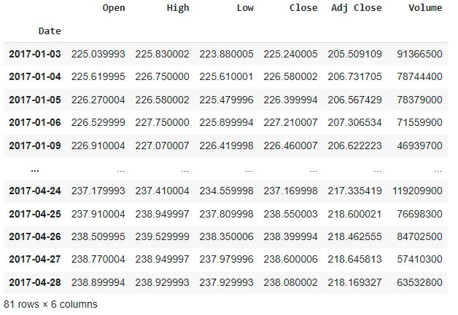

Figure 3.1.1 Description of dataset

* 1. **Algorithm**

**FACEBOOK PROPHET**

Time series forecast can be used in a wide verity of applications such as Budget Forecasting, Stock Market Analysis, etc. But as useful it is also challenging to forecast the correct projections, Thus can’t be easily automated because of the underlying assumptions and factors. The analysts who produced accurate forecasts are also rare, and there is a big market available for them because it requires a substantial understanding of statistics and data analysis and has prior experience of producing time series forecasting.

Facebook open-sourced its time-series forecasting tool called Prophet in 2017 which produced accurate forecasts as produced by skilled analysts with a minimum amount of human efforts. The Facebook prophet is available in the form of API in Python and R/

How Prophet Works:

Facebook Prophet using Additive Regressive models using the following four components:

y(t) = g(t) + s(t) + h(t) + \epsilon_t

• g(t): A piecewise linear or logistic growth curve trend. Prophet automatically detects changes in trends by selecting change points from the data.

• s(t): A yearly seasonal component modeled using the Fourier series and weekly seasonal component using dummy variable

• h(t): A user-provided list of important holidays.

• et: Error term used by the prophet.

* 1. **Libraries**
* Pandas
* Numpy
* Matplotlib
* Yahoo finanace
* Fb Prophet
* Streamlit
  1. **Data Processing**

**1.Load the data**

We’ll be using data from yahoo finance API and predict the values for future.

START = "2010-01-01"

TODAY = date.today().strftime("%Y-%m-%d")

def load_data(ticker):

data = yf.download(ticker, START, TODAY)

data.reset_index(inplace=True)

return data

**2.Selecting the specific data**

Since we’ll be predicting the “Close” value, we shall only take “Date” and “Close” column.

def plot_raw_data():

   fig = go.Figure()

   fig.add_trace(go.Scatter(x=data['Date'], y=data['Open'],

name="stock_open"))

fig.add_trace(go.Scatter(x=data['Date'], y=data['Close'], name="stock_close"))

   fig.layout.update(title_text='Time Series data with Rangeslider', xaxis_rangeslider_visible=True)

   st.plotly_chart(fig)

plot_raw_data()

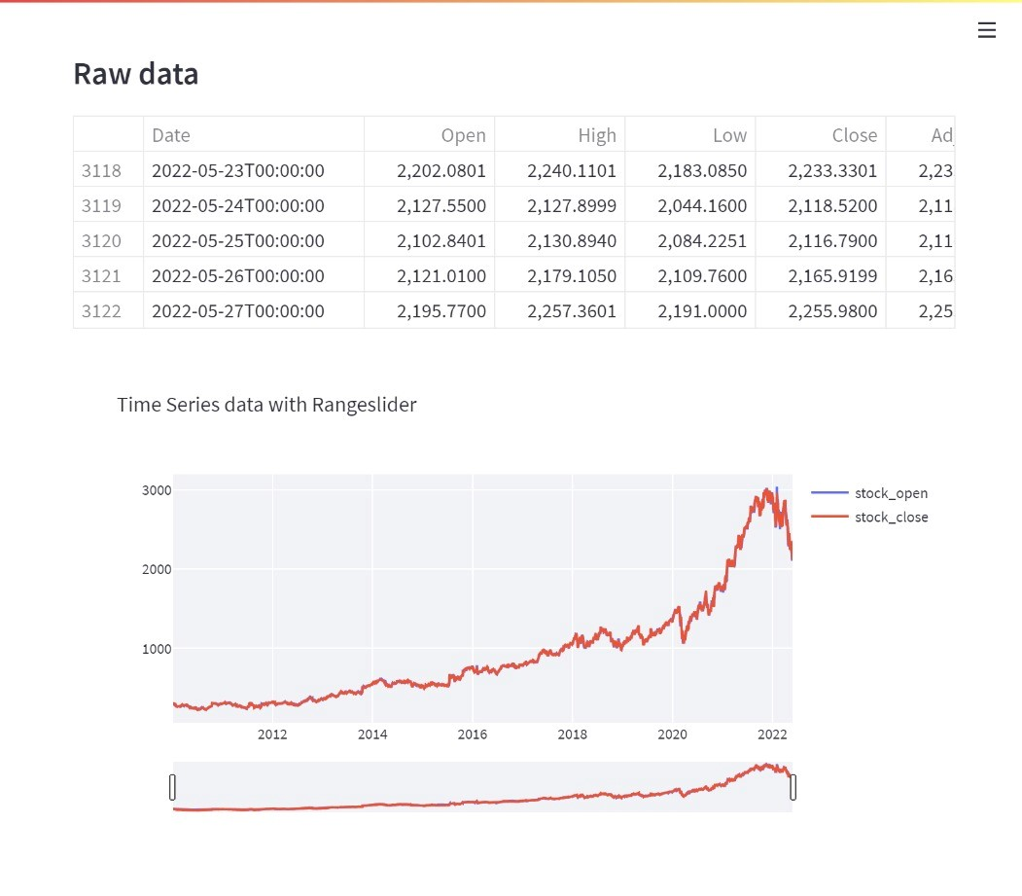Figure 3.4.1 Dataset after Data Processing

## Chapter 4

**OBSERVATION AND RESULTS**

### Training and Testing

* + - **Train Test split**

Then it will use some years' worth of data for training and a year's worth of data for testing, and will divide the data into train and test sets. The Facebook prophet API, which operates similarly to scikit-learn, is now available. The fit and predict functions are used to fit the dataset into the model and forecast future values.

split_date = "2019-12-31"

df_train = df.loc[df.ds <= split_date].copy()

df_test = df.loc[df.ds > split_date].copy()

df_train = data[['Date','Close']]

df_train = df_train.rename(columns={"Date": "ds", "Close": "y"})

* + - **Building the model**

We instantiate the Facebook prophet API, this prophet API works similar to sklearn model. It uses the fit function to fit the dataset into the model and predict function to forecast future values.

m = Prophet()

m.fit(df_train)

future = m.make_future_dataframe(periods=period)

forecast = m.predict(future)

## Results & Snapshots

### Prediction

### For the last step, we will ask the model to predict future values and then visualize the predictions.

model = fbp.Prophet()

model.fit(df_train)

forecast = model.predict(df_test)

model.plot(forecast)

model.plot_components(forecast)

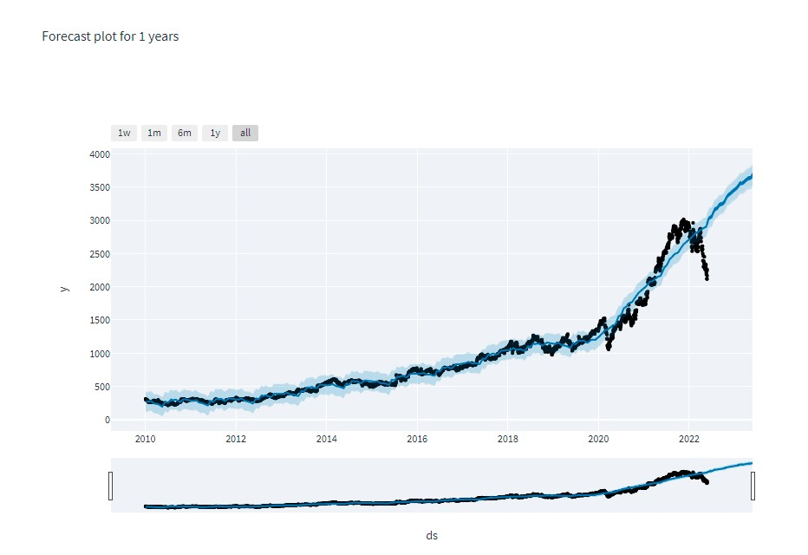

Figure 4.2.1 Forecast plot for next one year

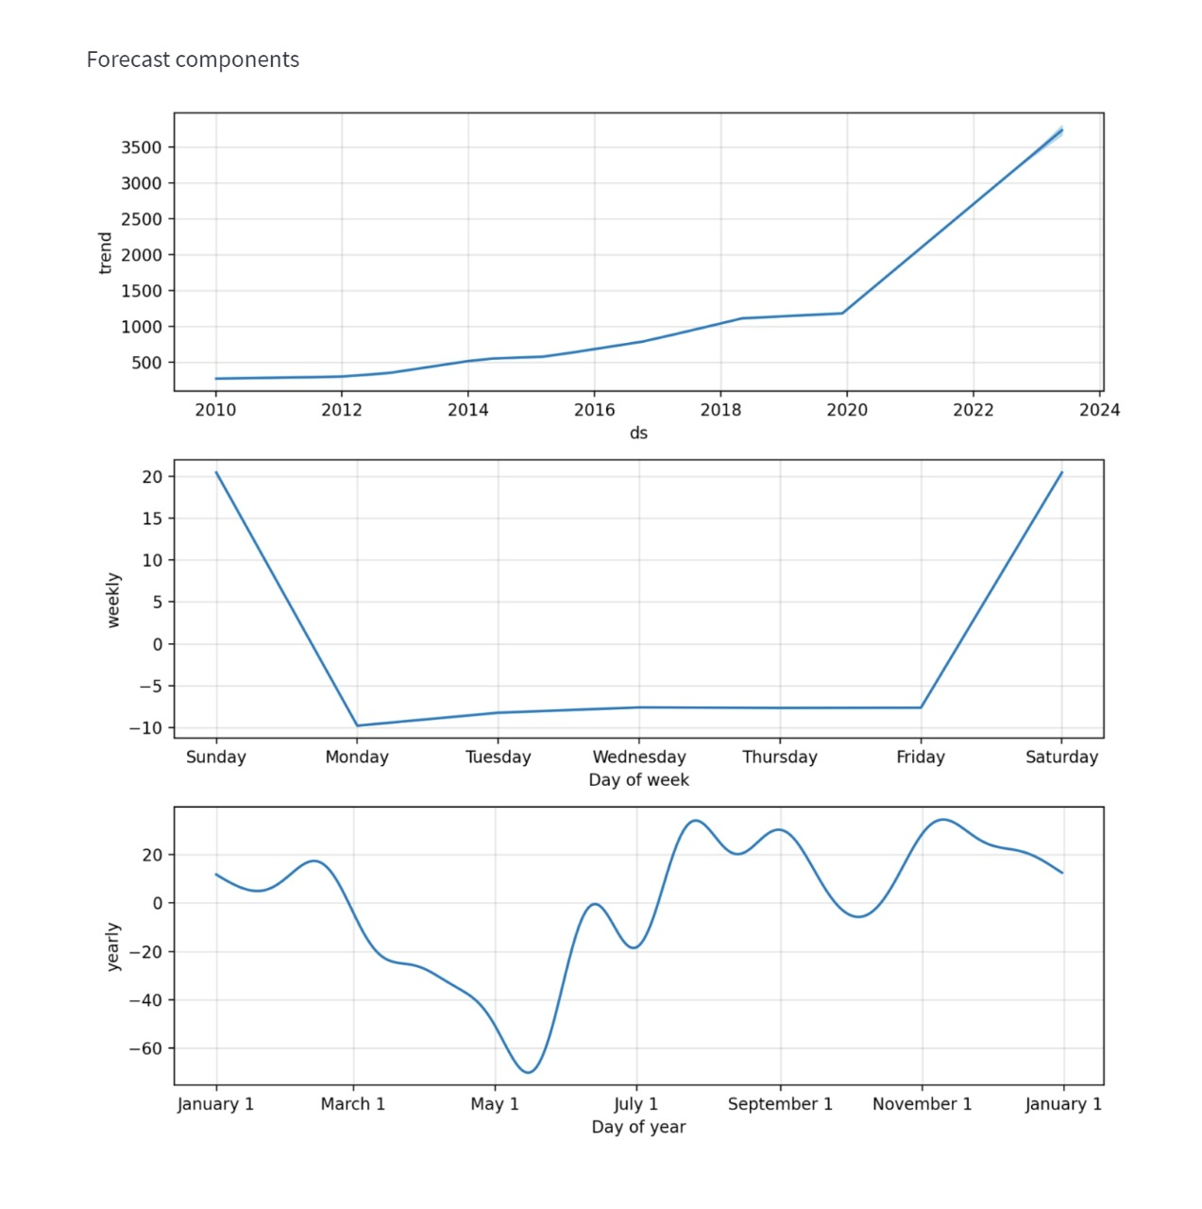

Figure 4.2.2 Forecast components plot

We calculate the mean square error and mean absolute error for the forecasted data.

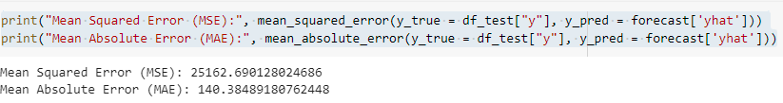

Figure 4.2.3 Mean Square and Mean Absolute Errors

Now, we calculate the mean absolute percentage error of our forecast, because it gives a better idea about how accurate our prediction is

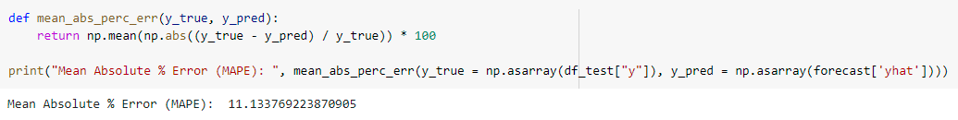

Figure 4.2.4 Error

**Chapter 5**

## CONCLUSION AND FUTURE ENHANCEMENT

### Conclusion

Living in a constantly evolving world, it has become a necessity to adapt to the world as change has become the norm. Harnessing the power of predicting the volatile stock market can bring some stability in an individual’s life. To do so requires the careful consideration of several factors, but the most important one of them all would be time. A novel method to exploit time of its insights is by employing the Prophet library. We concluded that historic data holds significance in terms of prediction and the closing price increased on certain months and days of the week. The complexity of time and the variance of seasonality has to be studied in depth in order to improve the existing models. Our future work would focus on studying the other impactful factors affecting the stock market and how best they can be integrated with time.

### Future Enhancement

* The LSTM model, which is frequently used for similar reasons, might be constructed.
* For maybe better outcomes, deep learning models could be constructed that consider financial news stories as well as financial characteristics such as a closing price, trading volume, profit and loss statements, and so on.
* For a better understanding, comparisons between different companies could be made.
* With better research and better tuning, more accurate results can be predicted. FB Prophet can be used to do efficient Time Series analysis, as it provides fast and simple to use methods for this purpose.

## Chapter 6

**REFERENCE**

[1].Ballings, M, Dirk Van den Poel and Nathalie Hespeels, Ruben Gryp (2015). Evaluating

multipleclassifiers for stock price direction prediction. Expert Systems with Applications, Elsevier Ltd.

[2]. Banco Santander dataset from Quandl website, <https://www.quandl.com/data/EURONEXT/SANT>

[3]. B. Cao, J. Zhao, Z. Lv, Y. Gu, P. Yang and S. K. Halgamuge (2020), Multiobjective Evolution of

FuzzyRough Neural Network via Distributed Parallelism for Stock Prediction, IEEE Transactions on

FuzzySystems, Volume 28.

[4]. D. Cabrera, R. Rubilar and C. Cubillos (2019). Resilience in the Decision-Making of an   
 ArtificialAutonomous System on the Stock Market, IEEE Access, Volume 7.

[5]. D Peng (2019). Analysis of Investor Sentiment and Stock Market Volatility Trend Based on Big

DataStrategy, International Conference on Robots & Intelligent System (ICRIS), Haikou, China